Udit Arora

Chandigarh university

LED control using bluetooth

**Circuit Diagram**:

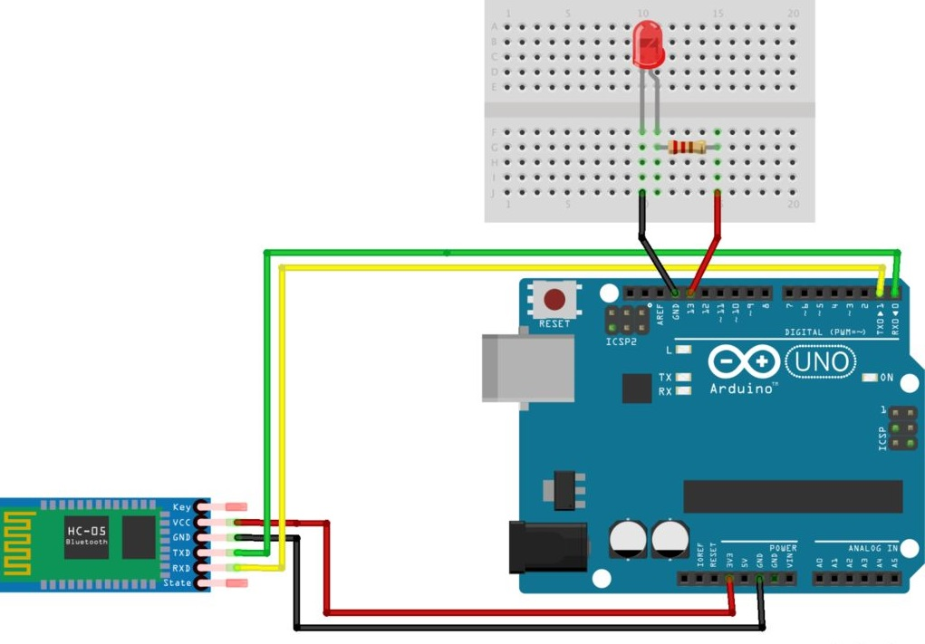

**Theory**:

In this experiment the transmitor(Tx) pin of bluetooth is connected to reiever (Rx) pin of the arduino as because we are transmitting signal from mobil through antenna and receiving it in bluetooth IC through antenna and and further signal is transmitted to arduino .

**Learning and observation :**

We use serial ports for receiving signals through bluetooth as because they have unique functionality I.e, 1 and 0.

**Problems and troubleshooting:**

1. Not selecting the correct port.

2. Improper connections.

**Precautions:**

1. Wiring should be proper.
2. Proper port should be choosed.
3. Problem uploading to arduino.

**Learning outcomes:**

The led turns on and off for 1 second each i.e., it blinks after every second.

Since 1000ms equals 1 second.

Arduinos are programmed via USB connections.